**IICS — SOURCE TO TARGET**

* Login to INFORMATICA INTELLIGENT XLOUD SERVICE (IICS) — Click DATA INTEGRATION.
* Create a new project/folder in EXPLORE — Give name and description.
* Go to the respected project folder .
* Click new — Click Mappings — Create a mapping to deploy data integration logic that is processed on the secure agent.
* Opens a window where we perform data transformation
* Change the name of the Mapping
* Click on Source — Go to Source in the properties — Select the connection — Source type Single — Select the object/table.
* Click on Target — Go to Target in the properties — Select the connection — Source type Single — Create the object/table.
* Save and Run — Go to Jobs and view the output.

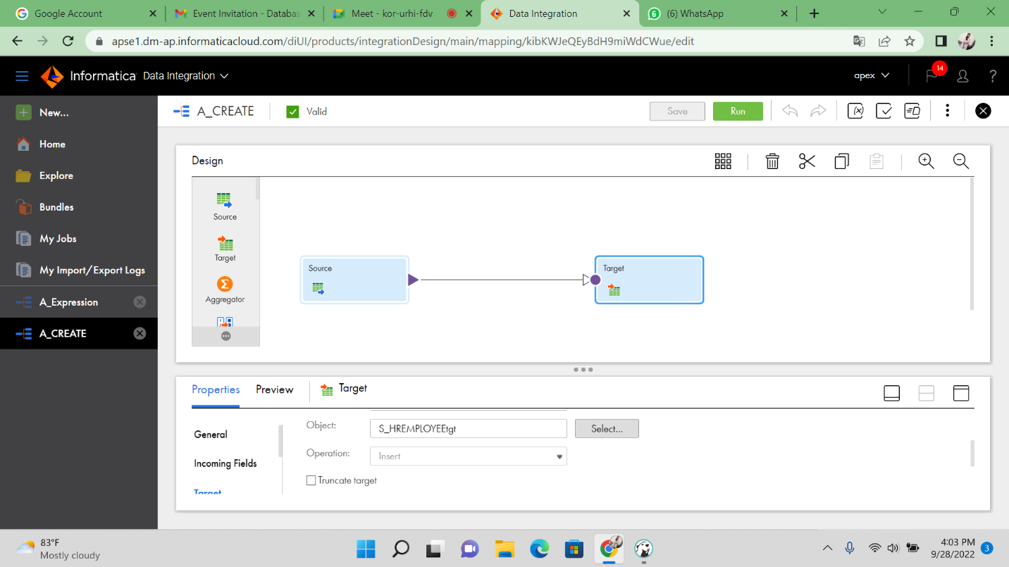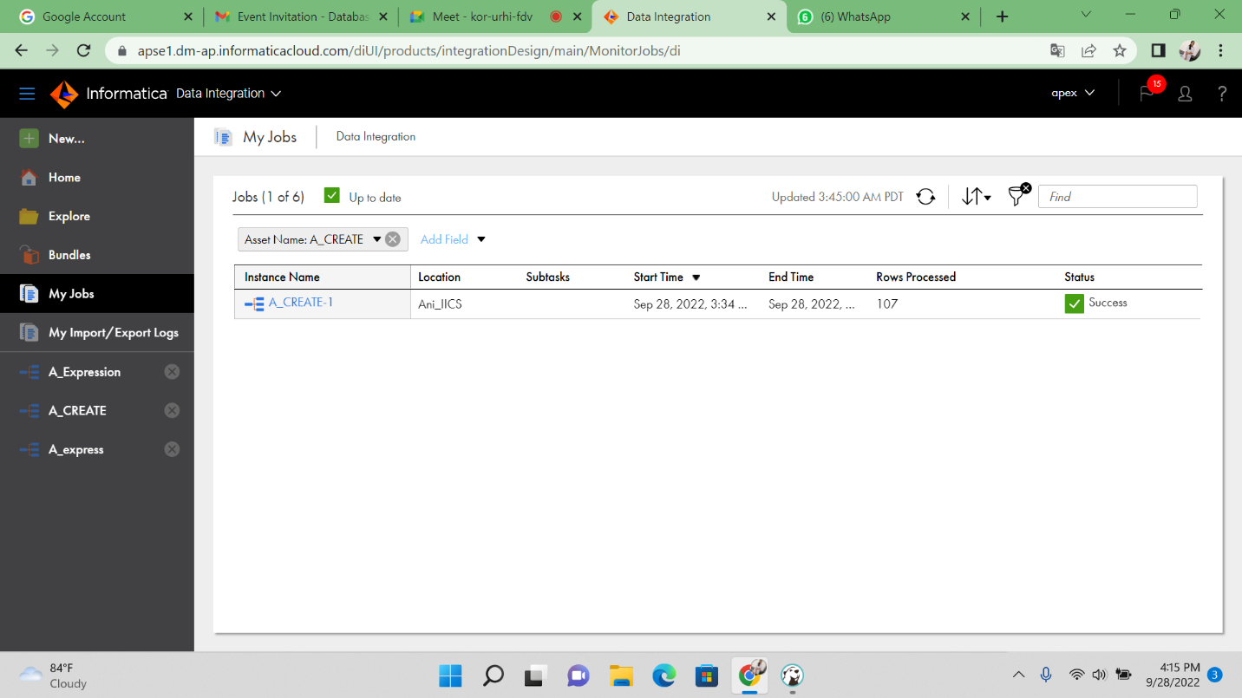

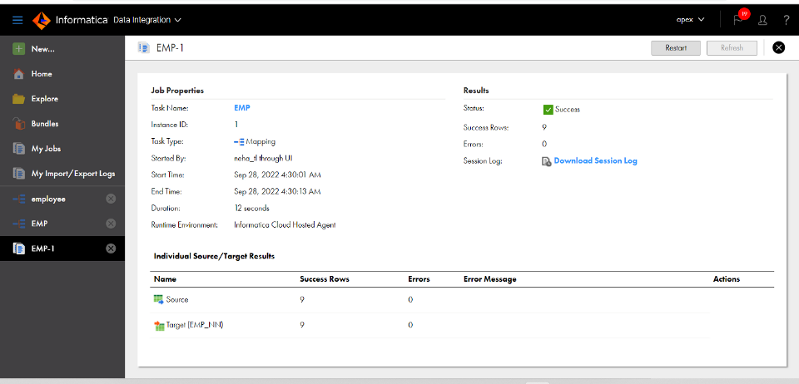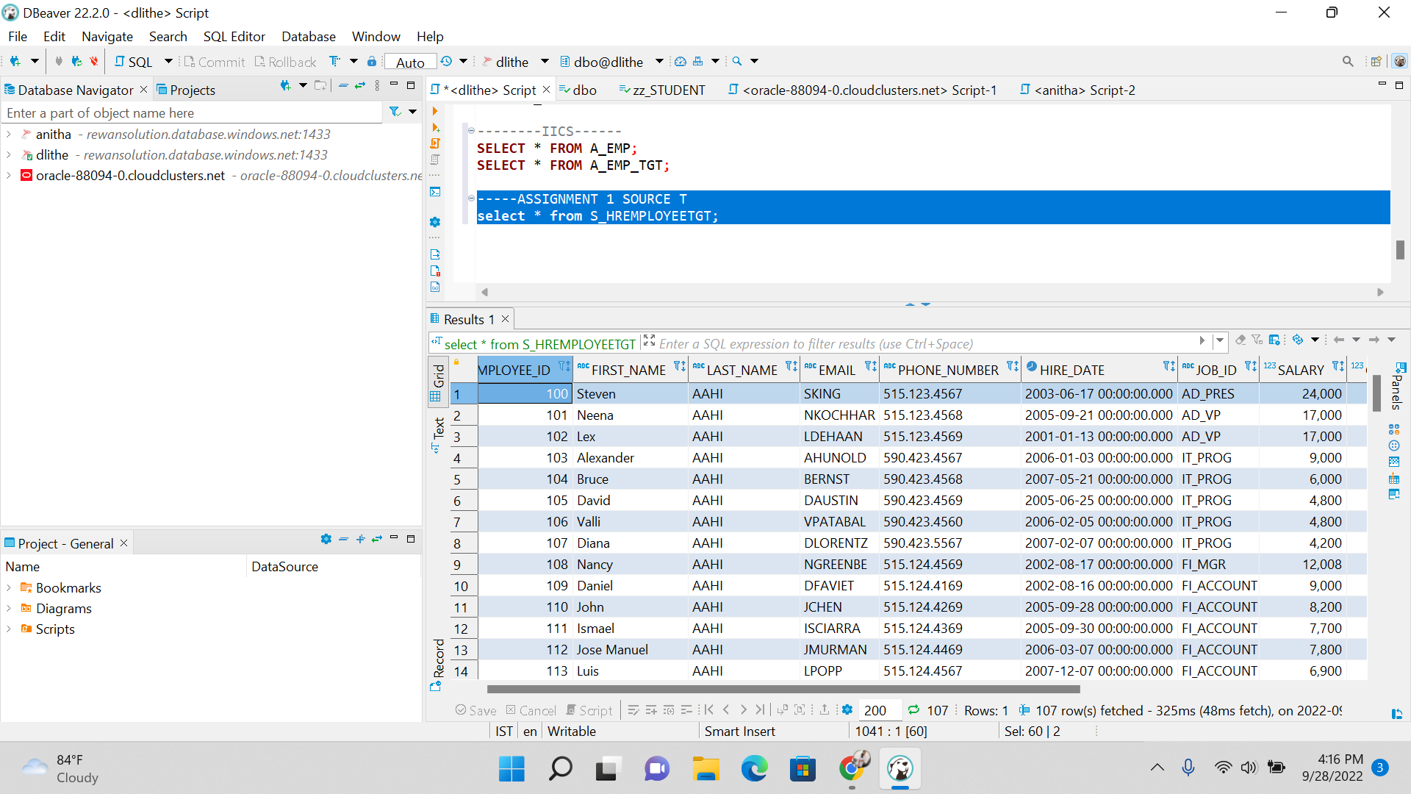

FINAL OUTPUT OF IICS WHEN LOADING DATA FROM SOURCE TO TARGET